Student Help Buddy

Your name(s) & email addresses

|  |  |
| --- | --- |
| Ewaoluwa Ajani | S00268840@atu.ie |
| Maksym Batrak | S00273952@atu.ie |
| Ewa Bender | S00273126@atu.ie |
| Jack Donaghy | S00268126@atu.ie |

Links to:

Trello Page

|  |
| --- |
|  |

GitHub Team Page

|  |
| --- |
|  |

Links to any data gathered or data analysis planned

|  |
| --- |
| <https://www.researchgate.net/publication/368301459_Student_Attention_and_Distraction_in_Community_College>  <https://www.researchgate.net/publication/387697885_THE_IMPACT_OF_TIKTOK'S_FAST-PACED_CONTENT_ON_ATTENTION_SPAN_OF_STUDENTS>  <https://www.researchgate.net/publication/388708713_The_role_of_self-regulated_learning_in_modelling_the_relationships_between_learning_approaches_FoMO_and_smartphone_addiction_among_university_students>  <https://www.tandfonline.com/doi/full/10.1080/2331186X.2024.2425205#d1e181>  <https://www.researchgate.net/publication/378436816_Teaching_Students_How_to_Study>  <https://files.eric.ed.gov/fulltext/EJ1097402.pdf> |

Problem to be solved

Summary of the Project solution

List of Project Requirements

Initial Design

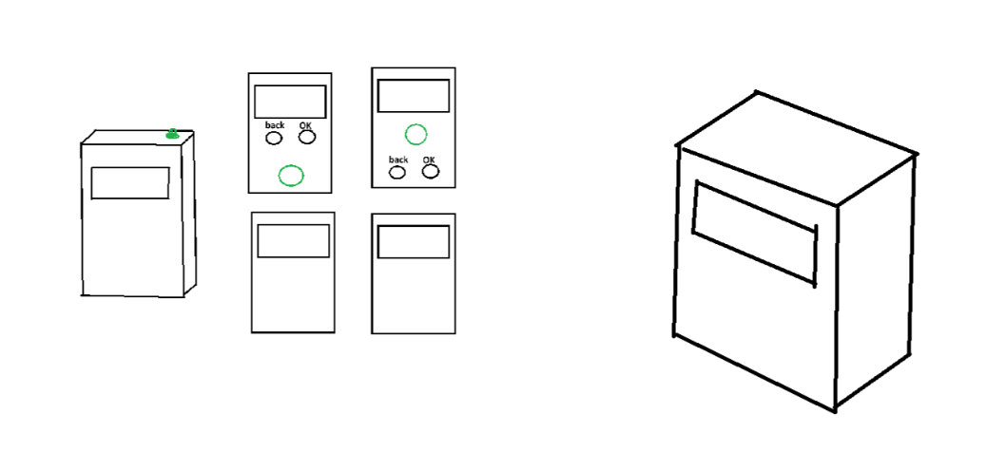

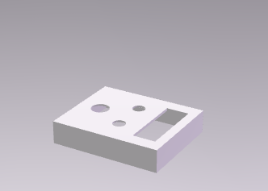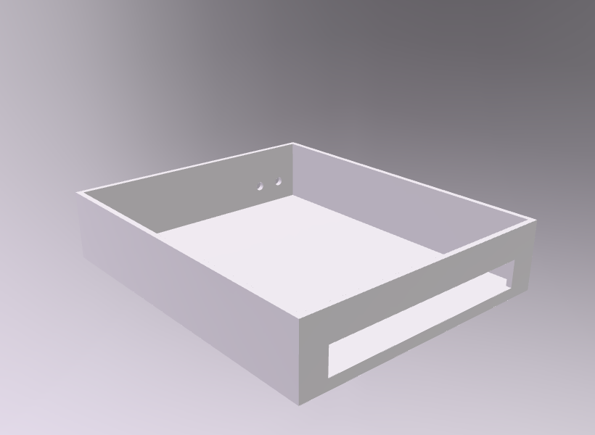

Implementation Plan to include equipment needed

Testing approach – how did you plan your software and hardware testing as well as evidence of tests carried out.

Security Analysis to prevent security holes

Future improvements planned and potential next steps in developing the idea further